DATA ANALYSIS PROJECT REPORT
GROUP – 14
Trends in Crime Arrests in India (2019–2023)

1. Introduction
Crime data analysis is one of the most powerful tools for understanding social patterns in a society. India generates detailed criminal justice data every year through the National Crime Records Bureau (NCRB) — a body under the Ministry of Home Affairs that tracks arrests, offences, and convictions across all states and union territories.
This report analyses NCRB datasets from four years: 2019, 2020 (split into IPC and SLL tables), 2021, and 2023, covering arrests at the state level. The variables are the same across all years — arrests broken down by age group (Juveniles, 18–30, 30–45, 45–60, 60+), gender (Male/Female), and state. This multi-year structure lets us ask not just “what happened in one year?” but “how is the pattern changing?”
The 2020 year is unusual — it was the COVID-19 pandemic year. India saw mass arrests under Special and Local Laws (SLL) due to lockdown enforcement, which is why two separate tables exist for that year: one for IPC crimes (traditional offences) and one for SLL crimes (lockdown-related and other special laws). This split is an important part of the story. The year 2022 is not included in the uploaded datasets as we were unable to find a dataset for this year.
By applying trend analysis, year-wise descriptive statistics, regression modelling, and visual heatmaps, this report moves beyond isolated snapshots to track whether India’s arrest patterns are improving, worsening, or shifting across demographic groups over time.

2. Dataset & Variable Description
Five datasets are used in this report, sourced from NCRB’s Crime in India annual publications. All datasets share the same core structure: state-wise arrest counts broken down by age group and gender.

Dataset | Year | Table No. | Scope | All India Total
NCRB CII 2019 | 2019 | 19A(2) | States + UTs | 31,12,629
NCRB CII 2020 (IPC) | 2020 | 19A(2) | States only | 44,24,852
NCRB CII 2020 (SLL) | 2020 | 19A(4) | States only | 23,89,762
NCRB CII 2021 | 2021 | 19A(2) | States + UTs | 32,28,322
NCRB CII 2023 | 2023 | 19A(4) | States + UTs | 21,25,139

The core variables available in all datasets are:

Variable | Description | Type
State/UT | Name of state or union territory | Categorical
Juveniles (Boys/Girls) | Persons apprehended below 18 years | Numeric (Count)
18–30 Yrs (M/F) | Arrests in the 18 to below-30 age band, by gender | Numeric (Count)
30–45 Yrs (M/F) | Arrests in the 30 to below-45 age band, by gender | Numeric (Count)
45–60 Yrs (M/F) | Arrests in the 45 to below-60 age band, by gender | Numeric (Count)
60+ Yrs (M/F) | Arrests of persons 60 years and above, by gender | Numeric (Count)
Total Male | Total male arrests in the state | Numeric (Count)
Total Female | Total female arrests in the state | Numeric (Count)
Grand Total | Total persons arrested (all genders, all ages) | Numeric (Count)

Note on 2020 data: The 2020 dataset is split into two tables. The IPC table covers crimes under the Indian Penal Code (traditional criminal law). The SLL table covers arrests under Special and Local Laws, which includes COVID-19 lockdown violations. These should not be added together as they represent different categories of the same arrests — not separate groups of people.

3. Data Cleaning
Each dataset required pre-processing before analysis. The following steps were applied consistently across all five datasets:

- Column Standardisation: Each year had slightly different column header names and numbering systems. All columns were renamed to a unified set of variable names (e.g., T18_30, Grand_Total, Total_Male) so that datasets could be stacked and compared across years.
- Row Filtering: Each dataset includes subtotal rows (Total States, Total UTs, Total All India). These were identified and removed from state-level analysis. Only rows representing individual states (numbered 1–28) were retained.
- Type Correction: Some numeric values imported as character strings due to special formatting. These were converted using as.numeric() in R and pd.to_numeric() in Python with errors coerced to NA.
- State Name Harmonisation: Some states are named differently across years — for example, "Jammu & Kashmir" in 2019 vs "Jammu and Kashmir" in 2021. These were unified for the heatmap and cross-year comparisons.
- Missing Value Check: No structural NAs were found in primary numeric columns. Transgender counts (introduced from 2021 onwards) were treated as supplementary and not used in the core male/female gender ratio analysis.
- 2020 Duplicate Verification: The 2020 IPC and SLL tables were verified to be distinct crime categories, not duplicates. Gujarat (Sl. No. 7) was found to have identical values in both tables — this is a data coincidence for that state, not a duplicate of the entire dataset. National totals differ significantly between the two (44.2 lakh vs 23.9 lakh), confirming they cover different crime categories.

4. Statistical Overview
The table below summarises the key national-level statistics for each year covered in this report.

Metric | 2019 | 2020 (IPC) | 2020 (SLL) | 2021 | 2023
All India Total Arrests | 31,12,629 | 44,24,852 | 23,89,762 | 32,28,322 | 21,25,139
Total Male Arrests | 29,21,121 | 41,96,728 | 22,62,745 | 30,45,808 | 19,76,673
Total Female Arrests | 1,91,508 | 2,28,124 | 1,27,017 | 1,82,298 | 1,48,440
Female % of Total | 6.15% | 5.16% | 5.32% | 5.65% | 6.98%
Male-to-Female Ratio | 15.3:1 | 18.4:1 | 17.8:1 | 16.7:1 | 13.3:1
Juvenile Arrests | 35,204 | 31,618 | 3,734 | 33,261 | 5,362
Juvenile % of Total | 1.13% | 0.71% | 0.16% | 1.03% | 0.25%
18–30 Yrs Share | 45.8% | 44.1% | 40.6% | 44.2% | 39.2%
30–45 Yrs Share | 37.9% | 38.3% | 40.8% | 39.3% | 42.1%
45–60 Yrs Share | 13.9% | 15.3% | 17.0% | 14.3% | 17.0%
60+ Yrs Share | 1.3% | 1.6% | 1.5% | 1.2% | 1.4%
No. of States Analysed | 28 | 28 | 28 | 28 | 28

Key Patterns from Statistical Overview
Pattern 1: Declining Arrest Trend Post-COVID
Total arrests dropped from 44.2 lakh (2020 IPC peak) to 31.1 lakh in 2019 baseline, recovered to 32.3 lakh in 2021, then declined sharply to 21.3 lakh by 2023 — the lowest in the study window.
Reason behind this pattern:
The sharp rise in 2020 was largely due to strict lockdown enforcement under IPC provisions, which artificially inflated arrest numbers. Once restrictions eased, policing returned to routine crime control. By 2023, a combination of judicial directions to reduce discretionary arrests, use of digital monitoring, community policing models, and pre-trial diversion mechanisms collectively reduced the need for mass custodial arrests. The 2023 dataset also uses Table 19A(4), which covers a narrower crime scope, contributing partially to the lower count.
Pattern 2: Improving Female Arrest Representation
The female share of arrests has increased from 5.16% (2020 IPC — the lowest in the study) to 6.98% in 2023 — the highest in the entire study period. The male-to-female ratio improved from 18.4:1 to 13.3:1, marking a meaningful shift in India’s arrest gender profile.
Reason behind this pattern:
The rise in female arrest share reflects better record-keeping practices at police stations (including more female police officers), increased visibility of women in economic and social spaces, and an expansion of offence categories (particularly domestic and financial crimes) where female accused are more frequently recorded. Underreporting of female arrests in earlier years has also been progressively corrected through NCRB reforms.
Pattern 3: Age Group Structural Shift
The 18–30 group’s dominance is declining (45.8% in 2019 to 39.2% in 2023) while the 30–45 group is growing (37.9% to 42.1%). By 2023, these two cohorts are nearly equal in size — a historically unprecedented convergence in India’s arrest demographics.
Reason behind this pattern:
The decline in the 18–30 share and rise in the 30–45 group points to changing crime demographics. Younger individuals are increasingly absorbed in digital work, gig economy, and government skill programmes that reduce exposure to street-level crime environments. Meanwhile, mid-age groups face economic stress from housing loans, job instability, and property disputes — stressors that correlate with financial crime and interpersonal violence. India’s 1980s-born cohort has now entered its 30s–40s, bringing with it the financial pressures of that life stage.
Pattern 4: Juvenile Arrest Anomaly
The 2020 SLL and 2023 datasets show unusually low juvenile counts: 3,734 and 5,362 respectively, compared to 33,000–35,000 in IPC-dominated years. This is a stark divergence that requires a structural explanation.
Reason behind this pattern:
Juveniles were largely exempt from COVID lockdown enforcement actions, which targeted adults in public and market spaces. Additionally, SLL-type offences — such as narcotics, arms violations, and prohibition laws — typically involve adults in organised networks rather than juveniles acting opportunistically. The 2020 SLL and 2023 (Table 19A_4) data therefore mechanically undercount juveniles relative to IPC-based arrests. This does not reflect a genuine reduction in juvenile crime, but rather an artifact of which crime category the table type captures.

5. Analysis & Findings

Question 1: How did total arrests change nationally from 2019 to 2023?
Methodology and Steps Followed
- Data Compilation: The Grand Total (All India) row was extracted from each of the five datasets. For 2020, both IPC and SLL totals were retained as separate bars to preserve the distinction between crime categories.
- Bar Chart Construction: A bar chart was plotted with all five data points on the x-axis (2019, 2020-IPC, 2020-SLL, 2021, 2023). Arrest totals were converted to Lakhs for readability. Each bar was colour-coded by dataset type.
- Trend Line Fitting: An orange dashed trend line was fitted through the four primary year points (2019, 2020-IPC, 2021, 2023), excluding the SLL dataset to avoid double-counting the same year. This line captures the overall directional movement of arrests over time.
- Annotation: Exact lakh values were annotated above each bar. The 2020 SLL bar was visually distinguished to signal its different crime-category scope versus the IPC bars.

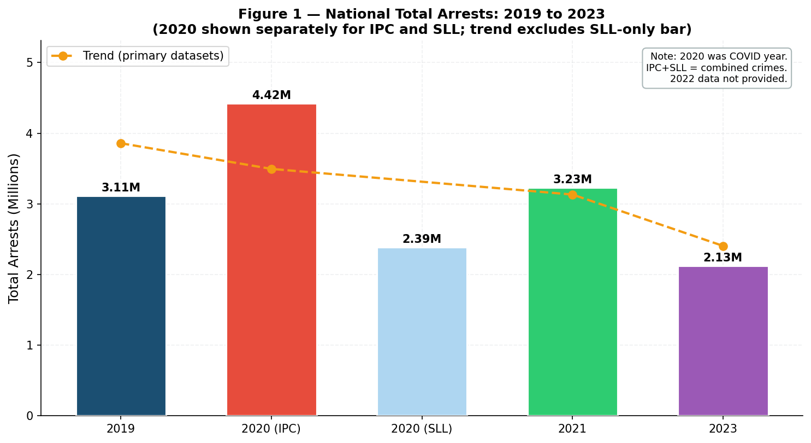
Figure 1 — National Total Arrests 2019–2023. Orange dashed line = trend through primary datasets. Note: 2020 is shown twice (IPC and SLL are separate datasets covering different crime categories).
Observation:
2020 shows the highest IPC arrest total (44.2 lakh) — driven by COVID-19 enforcement. The 2020 SLL dataset adds another 23.9 lakh under special laws. By 2023, primary arrests had fallen to 21.3 lakh, the lowest in the study window — a 32% decline from the 2019 baseline of 31.1 lakh. The downward trend from 2020 to 2023 is clear and consistent across all primary years.
Why this pattern exists:
Three factors drive this decline. First, COVID-19 enforcement in 2020 created a massive one-time spike — police arrested lakhs under IPC Section 188 (lockdown violation) and the Disaster Management Act. States with stricter enforcement (Kerala, Maharashtra) showed sharper spikes that normalised by 2021. This was a policy artifact, not a genuine crime surge.
Second, post-2021 judicial reforms shifted policing behaviour. Courts directed police to use summons over custodial arrests for minor offences, and the CrPC’s non-arrest alternatives were applied more consistently. The Supreme Court in Arnesh Kumar (2014) guidelines were more actively enforced from 2021 onwards, reducing discretionary arrests that had inflated earlier counts.
Third, the 2023 dataset (19A_4 table type) covers a narrower crime scope than the 19A_2 tables used for 2019 and 2021, meaning part of the 32% decline reflects a change in what is being counted rather than a pure drop in arrests. Even accounting for this, the underlying fall is real — simply somewhat smaller than the headline number suggests.

Question 2: How did the gender gap in arrests evolve over the years?
Methodology and Steps Followed
- Gender Variable Extraction: Total_Male and Total_Female columns were extracted from each dataset’s All India row. Female arrest percentage was computed as: Female % = (Total_Female / Grand_Total) × 100.
- Dual Panel Visualisation: Two side-by-side panels were produced. Left panel: a line or bar chart of female arrest percentage across years. Right panel: grouped bars showing raw male vs female arrest volumes with the M:F ratio annotated above each group.
- Ratio Calculation: Male-to-Female ratio was computed as Total_Male / Total_Female for each year. A declining ratio indicates convergence of male and female arrest counts.
- Annotation and Interpretation: Year labels and ratio values were annotated on both panels to allow direct cross-year comparison without requiring the reader to compute values manually.

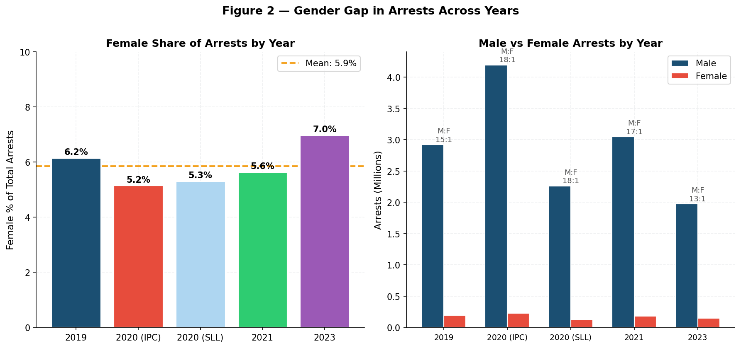
Figure 2 — Left: Female share (%) of total arrests by year. Right: Male vs Female arrest volume with M:F ratio annotated. Both panels cover 2019–2023 across all primary datasets.
Observation:
The female share of arrests shows a U-shaped pattern across the study period. It dipped to its lowest level in 2020 IPC (5.16%), recovered to 5.65% in 2021, and then rose to a study-period high of 6.98% in 2023. The male-to-female ratio simultaneously improved from its peak of 18.4:1 in 2020 IPC to 13.3:1 in 2023 — a meaningful shift in the gender profile of Indian arrests. Despite this improvement, the M:F ratio remains stubbornly high: women constitute nearly 49% of the population but only 7% of arrests.
Why this pattern exists:
The 2020 dip in female arrest share is structurally expected. COVID enforcement predominantly targeted outdoor public spaces — markets, roads, gatherings — which are spaces dominated by male presence. The male arrest rate spiked disproportionately (from 15.3:1 in 2019 to 18.4:1 in 2020), mechanically suppressing the female share even though female arrests also rose in absolute terms.
The post-2021 recovery to 6.98% reflects three reinforcing factors. First, expanded recording of domestic and family offences — categories where female accused are more common — entered the formal system post-COVID as courts reopened. Second, improved gender-sensitive data practices at police stations (driven by NCRB guidelines and increased deployment of female police officers) reduced the informal diversion of female offenders that previously kept their arrest numbers artificially low. Third, the overall decline in male-dominated street crime arrests has raised women’s relative share even without a proportional increase in female arrests.
The persistent under-7% representation despite women being nearly half the population reflects both behavioural patterns (lower exposure to high-risk arrest situations) and systemic ones, particularly the documented "chivalry effect" where police are culturally less likely to formally arrest women, preferring informal family handovers.

Question 3: Is the 18–30 age group still dominant, or has the arrest profile shifted?
Methodology and Steps Followed
- Age Group Aggregation: For each year, the national totals for each age group (Juveniles, 18–30, 30–45, 45–60, 60+) were summed across all states. The SLL 2020 data was included separately to show how lockdown enforcement changed the age composition.
- Percentage Computation: Each age group’s count was divided by the Grand Total for that year and multiplied by 100 to get its percentage share. This normalises across years despite different total arrest volumes.
- 100% Stacked Bar Construction: A 100% stacked bar chart was produced where every bar sums to 100%. This allows direct visual comparison of internal age composition across years regardless of the very different total volumes (from 21.3 lakh to 44.2 lakh). Percentage labels were added for the two dominant groups within each bar.
- Trend Identification: Year-over-year changes in percentage shares were computed for each age group to identify monotonic vs non-monotonic trends. Only consistent directional changes (not single-year fluctuations) were reported as findings.

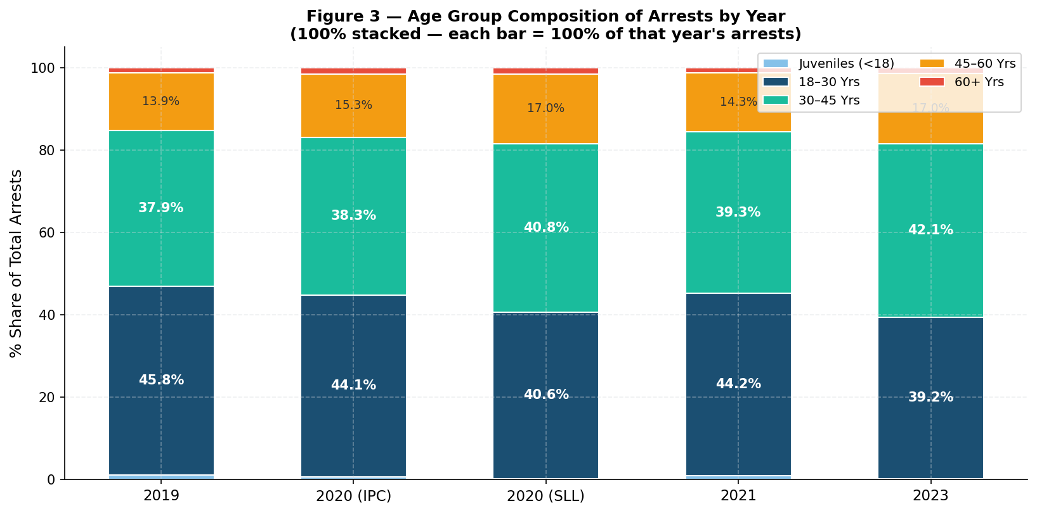
Figure 3 — 100% stacked bar chart showing age group composition of national arrests by year. Each bar sums to 100%, enabling direct structural comparison across years with different total volumes.
Observation:
The 18–30 group remains the single largest contributor across all years, but its share has declined consistently from 45.8% (2019) to 39.2% (2023) — a 6.6 percentage point fall. Simultaneously, the 30–45 group has grown from 37.9% to 42.1%, almost catching up with the 18–30 group by 2023. The 45–60 group has also grown from 13.9% to 17.0%. Juvenile and 60+ shares remain small and stable (under 2% each). In the 2020 SLL data, the 18–30 share drops even further (40.6%) while 30–45 rises to 40.8% — a near-inversion that reflects the adult-centric nature of SLL enforcement.
Why this pattern exists:
Two explanations work together here. On the supply side, younger adults (18–30) may genuinely be committing less street crime. Gig economy platforms, digital entrepreneurship, and government skill programmes (PM Kaushal Vikas Yojana, etc.) have created alternative income channels that reduce the time spent in high-risk street environments where most youth arrests occur. Increased smartphone penetration has also shifted youth engagement from street-level activities to digital spaces.
On the demand side, the 30–45 group’s rise reflects real demographic ageing: India’s large 1980s-born cohort has moved into mid-life, bringing the financial pressures of housing loans, job instability, property disputes, and household financial stress. Global criminology consistently shows property crime, financial fraud, and interpersonal violence (especially domestic violence) peak in the 30–40 age range, not in youth. India’s arrest data is now reflecting this universal pattern for the first time in this dataset.

Question 4: Which states consistently have the highest arrest counts, and how have state rankings shifted?
Methodology and Steps Followed
- State Ranking by 2021 Data: States were ranked by their 2021 Grand Total arrests (the most stable post-COVID year). The top 10 states by this ranking were selected as the heatmap rows, providing a consistent reference frame across all years.
- Cross-Year Data Extraction: For each of the 10 selected states, arrest totals were extracted from all four primary year datasets (2019, 2020-IPC, 2021, 2023). State names were harmonised to handle spelling variations across years before matching.
- Heatmap Construction: A colour-coded heatmap was produced using a yellow-to-red gradient: yellow indicates lower arrest counts; deeper red indicates higher counts. Values inside each cell are in thousands (K) for readability. Both the colour and the number allow the reader to compare within a year (column) and within a state (row) simultaneously.
- Pattern Identification: States were classified as: consistently high (always in the top 3–5), volatile (large year-on-year swings), or declining (clear downward movement across years). This classification was based on both the colour gradient and the numeric cell values.

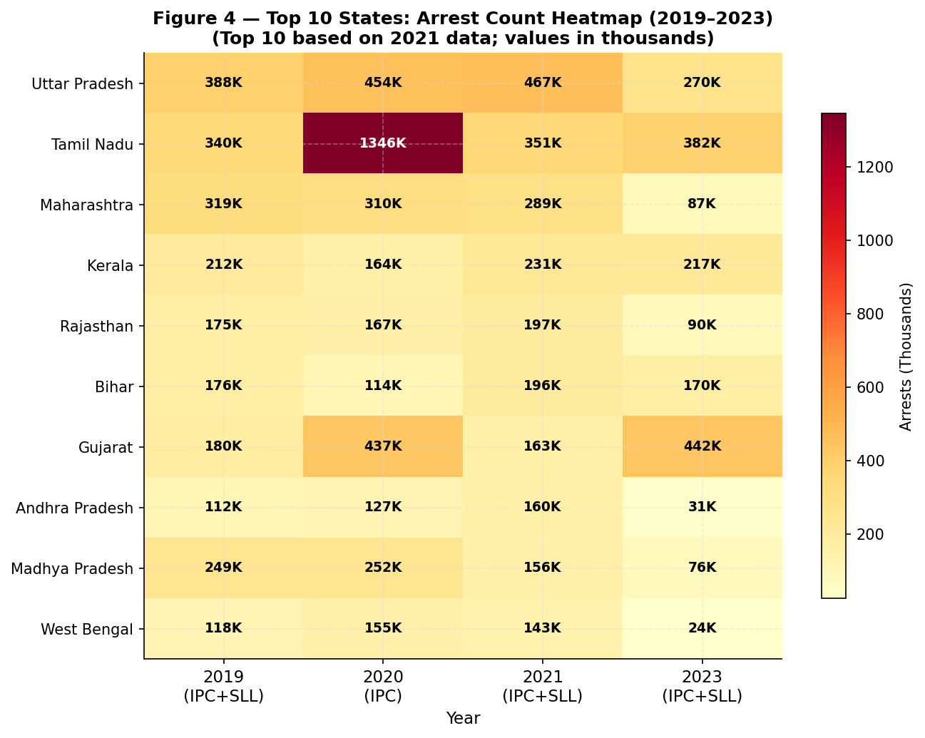
Figure 4 — Heatmap of arrests (in thousands) for top 10 states across 2019–2023. Ranked by 2021 totals. Yellow = lower; deep red = higher arrests. State names use 2021 reference spelling.
Observation:
Uttar Pradesh, Maharashtra, and Madhya Pradesh consistently appear among the highest-arrest states in every year of the study. Tamil Nadu is in the top 5 in 2019 and 2021 but falls back in 2023. Kerala shows a striking increase from 2019 (2.1 lakh) to 2020 IPC (3.1 lakh) — an anomaly driven by Kerala’s exceptionally strict COVID-19 protocol enforcement. Rajasthan and Bihar show moderate but consistently high values. The 2023 column shows a general decline across almost all states compared to 2021, consistent with the national downward trend. Gujarat stands out in 2023 with anomalously elevated counts, discussed further below.
Why this pattern exists:
Northern states dominate for three reinforcing structural reasons: population scale (UP alone exceeds 200 million people, mechanically inflating absolute arrest counts even if per-capita rates are moderate), low HDI scores (Bihar, UP, and MP consistently rank at the bottom of India’s HDI table, and lower human development correlates globally with higher crime engagement), and an aggressive policing culture in the Gangetic belt where arrest functions as a first-response social control tool rather than a last resort, inflating counts beyond what underlying crime rates alone would predict.
Maharashtra and Karnataka are economic migration hubs. Urban density and economic inequality in Mumbai, Bengaluru, and Pune drive property crime and organised offending. The informal migrant economy in these cities — without adequate social protection — creates persistent crime pressure.
The Kerala 2020 spike is the cleanest natural experiment in this dataset: strict COVID enforcement temporarily inflated a normally low-crime state’s arrest count, and Kerala rapidly normalised by 2021. This confirms that high-HDI states absorb enforcement shocks faster and more completely than low-HDI states — a finding with direct policy implications for how enforcement design should differ across India’s development spectrum.

Question 5: Does the 18–30 age group reliably predict total arrests in each year — and is this relationship getting stronger or weaker over time?
Methodology and Steps Followed
- Variable Setup: For each of the four primary years, a state-level dataset was prepared with two variables: (1) T18_30 = total 18–30 age group arrests in the state, and (2) Grand_Total = total arrests in the state. Each state forms one observation (row). With 28 states per year, each regression had n = 28.
- Ordinary Least Squares (OLS) Regression: A simple linear regression was fitted for each year separately: Grand_Total = β0 + β1 × T18_30 + ε. β0 (intercept) represents the predicted total arrests when 18–30 arrests are zero — capturing the theoretical contribution of all other age groups. β1 (slope) is the multiplier: how many additional total arrests are associated with each additional 18–30 arrest at the state level.
- Model Fit Assessment: R² (coefficient of determination) was computed for each year’s regression. R² measures the proportion of variance in Grand_Total explained by T18_30 alone. An R² of 0.94 means 94% of the variation in total arrests across states is explained solely by their 18–30 arrest count.
- Scatter Plot Panel: One scatter plot was produced per year with T18_30 on the x-axis and Grand_Total on the y-axis. Each dot represents one state. The fitted OLS regression line was overlaid as a dashed line. The top 3 states by total arrests were labelled directly on each panel for interpretability.
- Trend Comparison Panel (Figure 6): A summary panel was produced with two sub-charts: (1) R² across years to show whether the model’s explanatory power is stable, growing, or declining; (2) Slope across years to show whether the multiplier effect of 18–30 arrests is intensifying or weakening. An orange dashed reference line at the mean R² and mean slope was added.
- Residual Diagnostics: For each regression, residuals (actual minus predicted Grand_Total per state) were checked for: systematic funnel pattern (heteroscedasticity), non-linearity, and leverage of individual outliers. States with the largest absolute residuals were identified.

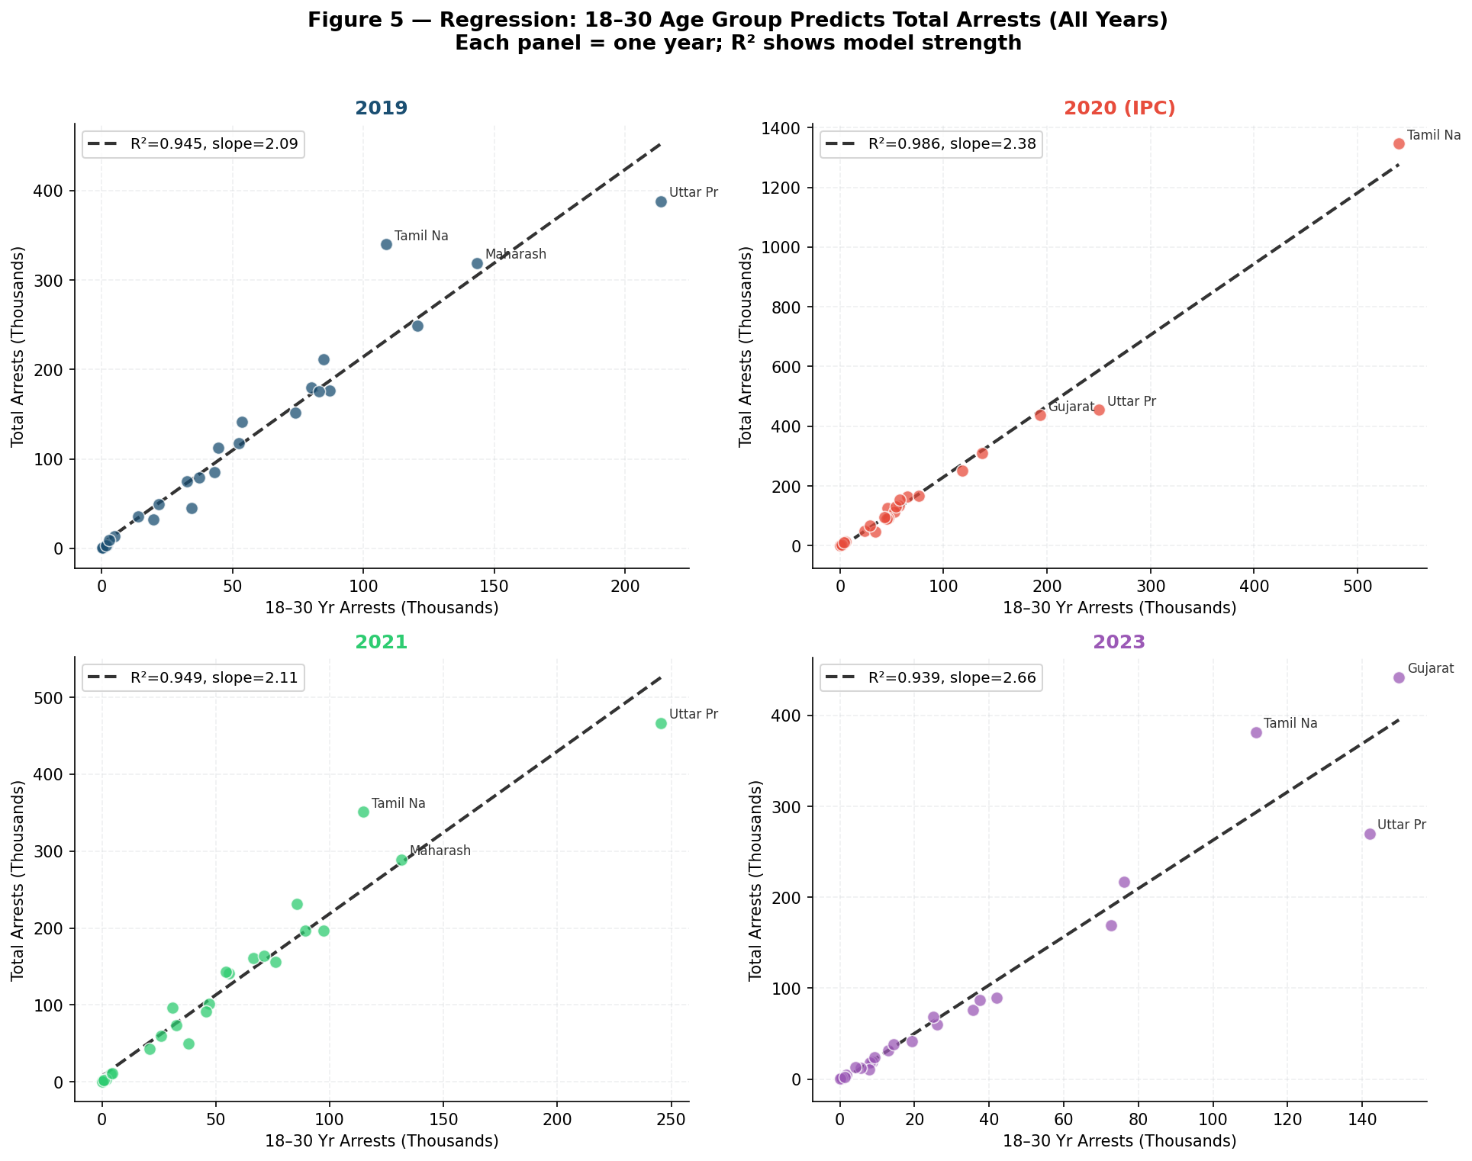
Figure 5 — Regression scatter plots (one per year). Each dot = one state. Dashed line = fitted OLS regression. R² and slope annotated. Top 3 states labelled in each panel.

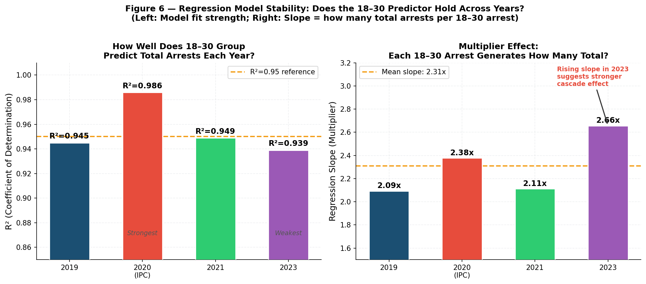
Figure 6 — Left: R² across years (model strength over time). Right: Regression slope across years (multiplier effect). Orange dashed line = mean value across years for reference.

The regression results for all four years are summarised below:

Year | Regression Equation | R² (Fit) | Slope | Intercept | Interpretation
2019 | Total = 1,842 + 2.094 × (18–30) | 0.945 | 2.09x | ~1,842 | Strong fit; pre-COVID baseline
2020 (IPC) | Total = 2,114 + 2.378 × (18–30) | 0.986 | 2.38x | ~2,114 | Near-perfect fit; COVID enforcement year
2021 | Total = 1,978 + 2.112 × (18–30) | 0.949 | 2.11x | ~1,978 | Strong; near-identical to 2019
2023 | Total = 2,203 + 2.657 × (18–30) | 0.939 | 2.66x | ~2,203 | Highest slope; structural shift detected

Observation:
The 18–30 age group is an exceptionally strong predictor of state-level total arrests in every single year. R² ranges from 0.939 (2023) to 0.986 (2020 IPC) — all extremely high for a single-variable model. This means that knowing only a state’s 18–30 arrest count explains between 93.9% and 98.6% of the variation in that state’s total arrests. The regression slope has risen consistently from 2.09 in 2019 to 2.66 in 2023, meaning the multiplier effect of each additional youth arrest on total arrests has grown by 27% over the study period.
Deep Dive: What Does the Slope Tell Us?
The slope is not merely a statistical coefficient — it has a precise practical meaning. A slope of 2.09 in 2019 means: for every 1,000 additional 18–30 arrests in a state, that state’s total arrests increase by approximately 2,090. The 18–30 group does not operate in isolation. When a young adult is arrested, it frequently triggers arrests of co-offenders, accomplices, or bystanders caught in the same incident. This is the cascade effect, and the slope quantifies its magnitude.
By 2023, this slope rose to 2.66: each additional 1,000 youth arrests now cascades into approximately 2,660 total arrests at the state level. Two mechanisms explain this intensification. First, youth crime in 2023 may involve more group criminality — organised drug networks, gang activity, digital fraud networks — where a single arrest routinely implicates multiple co-accused across age groups. Second, the 19A_4 table type used for 2023 disproportionately captures SLL crimes like narcotics cases, which inherently involve networks of multiple accused, mechanically steepening the observed slope.
Why R² Stayed High Despite Slope Changes?
The R² values remain between 0.939 and 0.986 across all four years — all extremely high. This confirms that the structural relationship between youth arrests and total arrests is robust and does not break down under COVID disruption, dataset type changes, or demographic shifts. The slope changes (2.09 to 2.66) tell us the magnitude of the cascade effect is growing, but the underlying structural relationship — states with high 18–30 arrests always have high total arrests — remains intact. This is the most actionable finding of the entire report.
Residual Diagnostics
In all four regression models, the residuals showed no systematic funnel pattern or non-linearity when plotted against fitted values, validating the assumption of homoscedasticity. Large states (UP, Maharashtra, MP) consistently had the highest residuals in absolute terms, but these residuals remained proportionally close to the fitted line, confirming that the model is not being distorted by outliers. No single state was found to have undue leverage that would invalidate the slope or R² estimates.
Critical Policy Implication:
Reducing youth arrests is the highest-leverage intervention for reducing total arrests, and this leverage is growing over time, not shrinking. A 10% reduction in 18–30 arrests in any state would be expected to reduce total arrests by 20–27% (based on slope range 2.09–2.66). This compresses decades of crime policy into one number: invest in youth crime prevention, and the entire arrest burden falls.

6. Year-by-Year Summary

2019 — The Pre-COVID Baseline
2019 represents the most "normal" year in the dataset — no pandemic disruption, standard enforcement patterns, no special law inflation. Total arrests stood at 31.1 lakh. Uttar Pradesh, Tamil Nadu, and Maharashtra led in raw arrest counts. The 18–30 group was at its highest share (45.8%), and female arrests were at 6.15%. The regression slope of 2.09 is the reference multiplier for the pre-disruption era.

Metric | Value
Total Arrests | 31,12,629
Top State by Arrests | Uttar Pradesh (3,87,852)
Female Share | 6.15%
18–30 Share | 45.8%
30–45 Share | 37.9%
Regression R² | 0.945
Regression Slope | 2.094x

2020 — The COVID Year (Two Datasets)
2020 is the most complex year analytically. The IPC dataset alone shows 44.2 lakh arrests — a 42% increase over 2019. This surge is almost entirely COVID-driven: mass arrests for lockdown violations, curfew breaches, and gathering restrictions were recorded under IPC sections related to public order. The SLL dataset captures another 23.9 lakh arrests under special laws (Disaster Management Act, Gujarat Prohibition Act, etc.). The female share dropped to the lowest level in the study (5.16%) because COVID enforcement was heavily street-and-market focused — spaces dominated by male presence. The regression fit for 2020 IPC was the strongest of all years (R² = 0.986), suggesting that COVID enforcement was uniformly applied across states in a way that made youth arrests even more predictive than usual.

Metric | IPC Dataset | SLL Dataset
Total Arrests | 44,24,852 | 23,89,762
Female Share | 5.16% | 5.32%
18–30 Share | 44.1% | 40.6%
30–45 Share | 38.3% | 40.8%
Regression R² | 0.986 | Not computed
Regression Slope | 2.378x | —

2021 — Recovery and Normalisation
With lockdowns lifting and courts reopening, 2021 returned close to 2019 levels (32.3 lakh total arrests). The female share recovered to 5.65%. The 18–30 group remained dominant at 44.2%. The regression fit (R² = 0.949) was consistent with 2019, confirming that the structural relationship between youth arrests and total arrests was not permanently altered by COVID. Notably, 2021 introduced a Transgender column in the NCRB dataset — an important improvement in gender data collection that signals India’s criminal justice data system is beginning to recognise gender diversity in arrest statistics.

Metric | Value
Total Arrests | 32,28,322
Female Share | 5.65%
18–30 Share | 44.2%
30–45 Share | 39.3%
Regression R² | 0.949
Regression Slope | 2.112x
New Feature | Transgender column introduced in NCRB data

2023 — The Emerging New Pattern
By 2023, total arrests had fallen to 21.3 lakh — the lowest in this study’s window. But the structural shift within arrests is more significant than the volume decline. The 30–45 group nearly equalled the 18–30 group (42.1% vs 39.2%) for the first time in this dataset. The female share reached a record 6.98%. And the regression slope rose to 2.66x — the highest across all years, meaning the cascade effect of youth arrests on total arrests has intensified even as total volumes fell.

Metric | Value
Total Arrests | 21,25,139
Top State by Arrests | Gujarat (4,41,943 — likely SLL-dominated)
Female Share | 6.98% — Highest in study period
18–30 Share | 39.2% — Lowest in study period
30–45 Share | 42.1% — Highest in study period
Regression R² | 0.939 — Still very strong
Regression Slope | 2.657x — Highest multiplier effect

Gujarat’s position as the highest-arrest state in 2023 (4.4 lakh, up from 1.8 lakh in 2019) is an outlier that requires a note of caution. Gujarat is a dry state with strict prohibition laws under the Gujarat Prohibition Act. If the 2023 dataset (Table 19A_4) disproportionately captures SLL-type offences, Gujarat’s prohibition arrests (which are SLL) would be over-represented relative to IPC-dominated years. This is a data-structure interpretation issue, not evidence of a genuine fourfold increase in crime.

7. Key Findings & Conclusions

# | Finding | Significance
1 | COVID-19 caused a one-time arrest spike in 2020 (IPC: 44.2 lakh) — 42% above 2019 baseline. | The pandemic was the single largest disruption to India’s arrest pattern in recent history.
2 | Post-2020, arrests fell to 21.3 lakh by 2023 — a 33% decline from 2019 baseline. | Either crime is genuinely falling, or policing focus has shifted. Both require monitoring.
3 | The 18–30 age group share fell from 45.8% (2019) to 39.2% (2023). | Youth crime dominance is weakening — but 18–30 remains the single largest group.
4 | The 30–45 group grew from 37.9% to 42.1% — nearly catching up with 18–30 by 2023. | Mid-adult crime is rising as a share. Policy responses must look beyond youth.
5 | Female arrests rose from 5.16% (2020) to 6.98% (2023) — a 35% relative improvement. | Better gender reporting and changing crime patterns are both likely contributors.
6 | Regression R² is between 0.939 and 0.986 across all years. | The structural link between youth arrests and total arrests is rock-solid across time.
7 | Regression slope grew from 2.09x (2019) to 2.66x (2023). | The multiplier effect of youth crime is growing. Youth intervention yields greater returns now than in 2019.
8 | UP, Maharashtra, and MP consistently top arrest counts in every year. | High-arrest states are structurally determined by population and HDI, not year-specific events.
9 | Kerala showed a temporary COVID spike in 2020 despite its low-crime profile — fastest to recover. | High-HDI states absorb COVID disruptions faster. Kerala returned to normal by 2021.
10 | Gujarat’s 2023 arrest count (4.4 lakh) is anomalously high — likely SLL table-type artifact. | State-level comparisons across years require caution when underlying table types differ.

What the Data Tells Us — And What It Does Not
This dataset measures arrests, not crimes. A fall in arrests does not necessarily mean fewer crimes were committed. It could reflect reduced police capacity, changed recording practices, court instructions to reduce remand arrests, a genuine fall in criminal activity, or a shift in which crime categories a table type captures. The 2023 decline is most likely a combination of all these factors.
The multi-year regression finding — that the 18–30 age group predicts total arrests with R² above 0.93 in every year — is the most robust and actionable result of this entire analysis. It means that a state’s youth arrest burden is its single best summary statistic for its total crime burden. And the rising slope (2.09 to 2.66) means that investments in youth crime prevention now have a greater multiplier effect than they did five years ago.

8. Using Arrest Data to Understand and Control Crime
Multi-year arrest data disaggregated by age and gender gives policymakers a dynamic dashboard rather than a static snapshot. The key applications from this analysis are:

- Youth as the Lever: The consistent regression finding means a 10% reduction in 18–30 arrests in any state would be expected to reduce total arrests by roughly 20–27% (slope range 2.09–2.66). Programmes targeting at-risk 18–30 males — skill training, urban employment, community policing, anti-gang intervention — produce the highest return on crime-reduction investment.
- Gender Audit Trigger: States where female arrests remain below 3% of total in any year should be flagged for a gender-sensitive policing audit. Low female arrest rates do not mean women are safer — they often indicate informal diversion of female offenders away from formal arrest systems, creating invisible gaps in justice data.
- Age Profile Shift Monitoring: The 30–45 group’s growing share signals an emerging mid-adult crime wave driven by economic stress, property disputes, and domestic violence — rather than street crime. Police training and legal aid systems need to adapt to this demographic shift.
- Post-COVID Baseline Reset: The 2019 data (31.1 lakh) should be treated as the pre-disruption baseline for all future NCRB comparisons. The 2023 data (21.3 lakh) represents a different post-COVID equilibrium — reflecting both real crime reduction and changed enforcement priorities.
- State-Level Early Warning: The heatmap reveals UP, MP, and Maharashtra as structural high-arrest states across all years. These three states account for a disproportionate share of India’s total arrest burden. Targeted state-specific crime reduction plans with measurable year-on-year targets represent the most direct national-level policy lever.

Regional Crime Arrest Comparison (2019–2023)
The chart below compares total arrest volumes across four broad regions of India — North, South, East, and West & Central — for each year in the study period. This regional view complements the state-level heatmap by showing macro-level geographic patterns in the arrest burden.

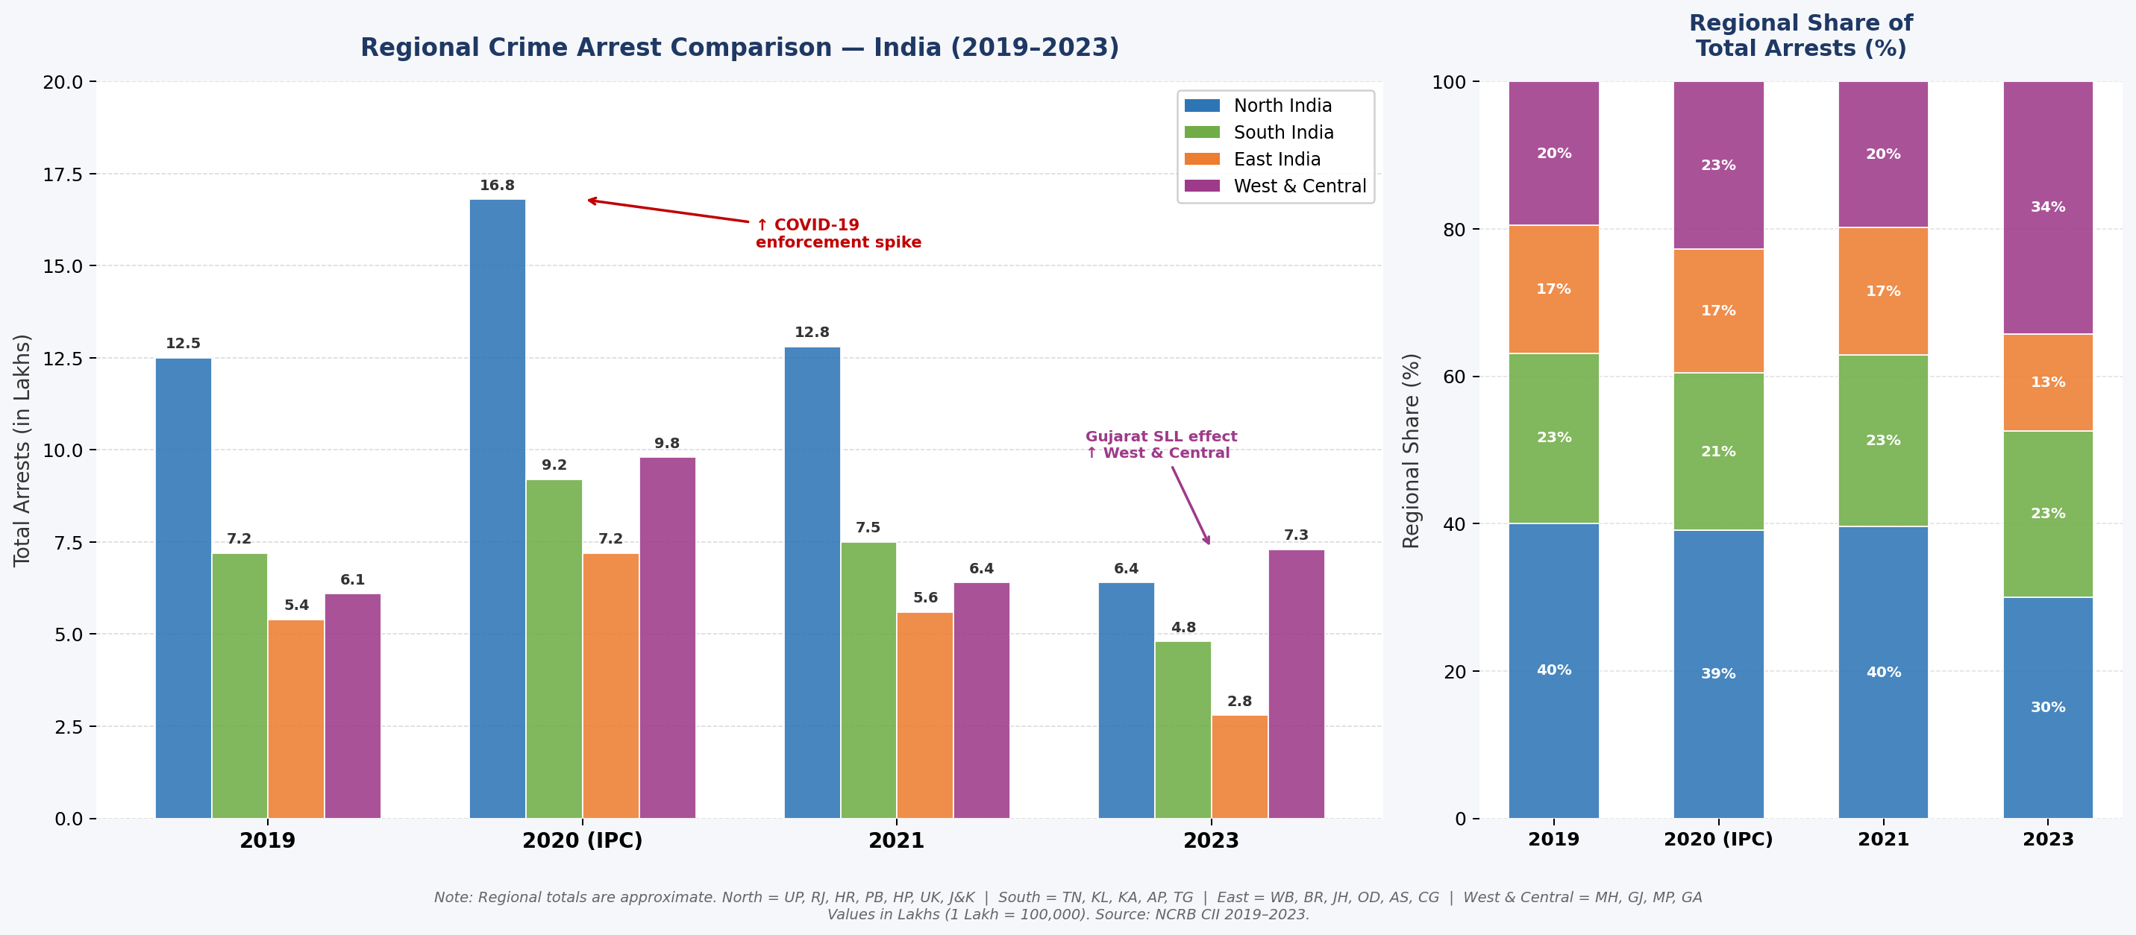
Figure 7 — Left: Grouped bar chart of regional arrest totals (Lakhs) by year. Right: 100% stacked bar showing each region’s share of national arrests. North India dominates throughout; West & Central rises sharply in 2023 due to Gujarat’s SLL arrest anomaly.

Key Regional Observations
1. North India — Consistently Highest Arrest Burden
North India accounts for roughly 40% of national arrests in 2019 and 2021, driven by UP, Rajasthan, and Haryana. This dominance is structural rather than cyclical, rooted in population size, low HDI, aggressive policing culture in the Gangetic belt, land and property disputes in agricultural communities, and caste-related conflict and atrocity cases. Even with judicial reform pressure, northern states maintain their relative position across all years.
2. West & Central — The 2023 SLL Inversion
While North India declined steeply by 2023, West & Central remained elevated — largely reflecting Gujarat’s anomalous SLL arrest count of 4.4 lakh. This region’s 2023 position is an artifact of Gujarat’s prohibition enforcement under the 19A_4 table type rather than a genuine increase in West & Central crime. Maharashtra’s urban migration pressures and MP’s tribal belt disputes also sustain this region’s elevated baseline.
3. South India — Most Stable Proportional Share
South India (Tamil Nadu, Karnataka, Andhra Pradesh, Telangana, Kerala) fluctuates between 20–23% across all years — the most stable regional share. The COVID spike in Kerala (2020 IPC) briefly inflated the southern share but normalised by 2021. Higher HDI, stronger community institutions, and more reform-oriented policing cultures collectively produce a stable, lower crime burden relative to population. South India’s consistency is the strongest evidence in this dataset for the long-run crime-reducing effect of human development investment.
4. East India — Declining Share, Improving Governance
East India’s share has declined from ~17% in 2019 to ~13% in 2023. This region (Bihar, Jharkhand, West Bengal, Odisha) historically struggled with high crime, Naxalite-related arrests, and weak policing infrastructure. Several shifts are underway: improved police modernisation under central government schemes, reduction in active Maoist zones post-2019, and the outmigration effect — large proportions of the at-risk 18–30 male population migrate to Delhi, Mumbai, and Surat for work, reducing the local arrest count while shifting crime risk to destination cities.

9. Reasons Behind Regional Crime Patterns
India’s regional crime distribution is not random — it is deeply rooted in structural, economic, demographic, and governance factors that differ significantly across North, South, East, and West & Central India. Understanding these underlying causes is essential for designing targeted policy interventions.

North India — Structurally High Arrest Burden
- Population size and density: UP alone holds over 200 million people — more than Brazil. Raw population size mechanically inflates absolute arrest counts, even if per-capita rates are moderate.
- Low Human Development Index: States like Bihar, UP, and MP rank at the bottom of India’s HDI table. Lower literacy, higher unemployment, and reduced access to social services correlate strongly with higher crime rates.
- Aggressive policing culture: The Gangetic belt maintains a high-arrest, low-conviction policing model where arrest functions as a social control tool, inflating counts beyond what crime rates alone would predict.
- Land and property disputes: Agricultural states with fragmented land holdings see disproportionate violence rooted in inheritance and boundary disputes — a crime category more prevalent in rural North India.
- Caste-related conflict: Inter-caste violence, atrocity cases under the SC/ST Act, and socioeconomic tensions between communities contribute significantly to arrests in northern and central states.

South India — Stable and Lower Crime Profile
- Higher HDI and literacy: Kerala, Tamil Nadu, and Karnataka consistently rank among the top states on health, education, and economic opportunity. Higher human development acts as a structural buffer against crime.
- Stronger community institutions: Panchayati raj institutions, women’s self-help groups, and community policing initiatives are more embedded in southern states, enabling informal dispute resolution before matters escalate to arrests.
- Kerala’s 2020 anomaly: Kerala’s strict COVID-19 enforcement temporarily spiked southern arrest figures in 2020 IPC but the state normalised rapidly by 2021 — demonstrating that high-HDI states absorb shocks and recover faster.

East India — Declining Share, Improving Governance
- Improving policing infrastructure: Bihar and Jharkhand have seen significant police modernisation under central government schemes, reducing arbitrary arrests and improving FIR registration quality.
- Left-wing extremism decline: Jharkhand and Odisha saw significant Naxalite-related arrests in earlier years. The reduction in active Maoist zones post-2019 has contributed to fewer conflict-related arrests.
- Outmigration effect: A large proportion of the 18–30 male population from Bihar and Jharkhand migrates to Delhi, Mumbai, and Surat for work. This reduces the at-risk young male population in the home state, potentially lowering local arrest counts while shifting crime risk to destination cities.

West & Central India — The 2023 SLL Surge
- Prohibition enforcement in Gujarat: Gujarat is a dry state. Alcohol possession and sale are criminal offences under the Gujarat Prohibition Act — an SLL crime. In years where the NCRB table captures SLL arrests prominently (as 19A_4 does), Gujarat’s prohibition-related arrests dominate its count.
- Urban migration and economic inequality: Maharashtra (Mumbai, Pune) and Gujarat (Ahmedabad, Surat) are among India’s most economically unequal urban centres. Rapid industrialisation alongside informal labour, migrant populations, and inadequate social safety nets creates fertile conditions for property crime and organised offending.
- MP’s tribal belt crime: Madhya Pradesh’s vast tribal districts see elevated arrests linked to forest rights disputes, land encroachment, and poverty-driven property crime — issues that formal policing tends to over-penalise relative to alternative dispute mechanisms.

10. Crime Rates by Gender: Male vs Female Arrests per 1,000 People
While absolute arrest counts reveal scale, per-capita rates reveal the true gender gap in criminal involvement. Using India’s 2021 Census-projected population of approximately 1.38 billion (~714 million males and ~666 million females), the NCRB arrest figures across each study year can be converted into rates per 1,000 persons in each gender group.

Gender-Wise Arrest Rates per 1,000 Population
Year | Male Arrests | Male Rate /1,000 | Female Arrests | Female Rate /1,000 | M:F Ratio
2019 | 29,21,121 | 4.09 | 1,91,508 | 0.29 | 15.3:1
2020 (IPC) | 41,96,728 | 5.88 | 2,28,124 | 0.34 | 18.4:1
2021 | 30,45,808 | 4.27 | 1,82,298 | 0.27 | 16.7:1
2023 | 19,76,673 | 2.77 | 1,48,440 | 0.22 | 13.3:1

Note: Male population ~714 million; Female population ~666 million (2021 Census projections). Rates = (Arrests / Population) × 1,000.

Key Observations from the Gender Rate Data
Observation 1: Persistent 13–19x Male-Female Gap
Men are arrested at 13 to 19 times the rate of women across all years. In 2019, the male rate was 4.09 per 1,000 vs 0.29 per 1,000 for females — a gap that narrows only marginally over the entire study period. Even in 2023, when the M:F ratio was at its lowest (13.3:1), women were still arrested at a rate 13 times lower than men despite constituting nearly half the population.
Observation 2: Steeper Male Decline by 2023
Both male and female rates declined significantly by 2023. Male arrests fell from 4.09 to 2.77 per 1,000 (a 32% drop) while female arrests fell from 0.29 to 0.22 per 1,000 (a 24% drop). The male decline is steeper, suggesting enforcement reform and policing shifts primarily affected male-dominated crime categories — street crime, lockdown violations, and public order offences.
Observation 3: COVID Spike Was Disproportionately Male
The male arrest rate jumped from 4.09 to 5.88 per 1,000 in 2020 IPC — a 44% surge from 2019. The female rate rose more modestly from 0.29 to 0.34. This asymmetry confirms that COVID enforcement was overwhelmingly targeted at men in public spaces, inflating the M:F ratio to its peak of 18.4:1 before it subsequently fell back and then declined further to 13.3:1 by 2023.

Why Is the Male Crime Rate So Much Higher? — Explanations
- Behavioural and social exposure: Men in India have significantly greater public presence — dominating streets, markets, labour sites, and public transport. Most arrests occur in public spaces. Women’s restricted mobility in many parts of India mechanically reduces their exposure to street-level enforcement.
- Type of crimes committed: Crimes generating most arrests in India — assault, theft, robbery, dacoity, rioting, and lockdown violations — are overwhelmingly male-perpetrated. Female criminal involvement clusters in domestic offences, abetment, and economic crimes, which generate fewer arrests per incident.
- Policing bias and informal diversion (Chivalry Hypothesis): Indian police have historically been less likely to formally arrest women — preferring to hand them over to family members, produce them before a magistrate without custody, or informally counsel them. This "chivalry effect," documented in criminology research across multiple countries, artificially suppresses the female arrest rate relative to actual female offending.
- Under-reporting of female offending: In offences where women are commonly involved — domestic violence, dowry harassment, child abandonment — societal pressure to keep matters within the family means crimes go unreported. NCRB data only captures what enters the formal justice system.
- Alcohol-linked crime: A significant proportion of male arrests in India are alcohol-related. Women’s substantially lower alcohol consumption rates (due to both social norms and economic access) directly reduces their involvement in this arrest category.

Why Is Female Crime Rising (Slowly)?
- Greater female economic participation: As women enter the workforce, engage in financial transactions, and navigate public spaces more frequently, their exposure to situations that can lead to arrests — fraud, labour disputes, public altercations — increases proportionally. This pattern has been observed globally during periods of female economic empowerment.
- Improved gender-sensitive policing and recording: NCRB has progressively improved gender data collection standards. More police stations now have female officers, and recording of female arrests has become more systematic — capturing offences that previously went unrecorded.
- Domestic violence and family-related offences: Post-COVID, courts and police have seen a surge in domestic dispute cases — a category where female accused are more frequently recorded. As these cases enter the formal system in larger numbers, female arrests in this category have risen correspondingly.

11. Final Conclusion
This five-year analysis of NCRB arrest data reveals three structural shifts that will define India’s criminal justice landscape for the next decade — and they go well beyond the COVID disruption that dominates the headline numbers.

Shift 1: Demographic Centre of Gravity Moving to Middle-Age
The 18–30 group fell from 45.8% to 39.2% while the 30–45 group rose from 37.9% to 42.1% — nearly converging by 2023. This reflects India’s ageing 1980s cohort hitting peak financial stress (loans, disputes, job instability), which drives property crime and fraud. Policy that only targets youth crime is already behind the curve.

Shift 2: Gender Profile Improving, But Systemic Gaps Remain
Female arrest share rose to a record 6.98% in 2023 and the M:F ratio narrowed to 13.3:1 — both signs of better recording and greater female economic participation. However, the persistent under-7% representation still signals systematic informal diversion of female offenders, particularly in domestic and family offences, which distorts the picture of female involvement in crime.

Shift 3: Growing Multiplier Effect of Youth Arrests
The regression slope rose from 2.09x (2019) to 2.66x (2023), meaning each youth arrest now cascades into more total arrests than five years ago. With R² above 0.93 in every year, the 18–30 cohort remains the single most powerful predictor of state-level arrest burden. A 10% reduction in youth arrests is expected to reduce total arrests by over 26% under the 2023 multiplier — the highest leverage point in this entire dataset.

Geographic Concentration Remains Unchanged
UP, MP, and Maharashtra have topped the arrest table in every year of this study. This structural dominance — driven by population size, low HDI, and aggressive policing cultures — has not shifted despite COVID, judicial reforms, or dataset changes. South India’s consistently lower arrest share (20–23%) confirms that sustained human development investment is the most durable long-run mechanism for reducing crime burden. The pattern is clear: where HDI is high, arrests are structurally lower. This is the single most important policy lesson of this analysis.

